# UB Social login

**1-Twitter:-**

Username: - Cliffkeen2

Password: - @Password1

Associate phone no: - 8437761057

Associate Email id: - [ckub2019@gmail.com](mailto:ckub2019@gmail.com)

Developer Account URL: - <https://developer.twitter.com/en/portal/dashboard>

**Twitter URL:-**  
<https://developer.twitter.com/en/portal/projects/1543898368006451201/apps/16152797/settings>

**Step-1** Click on edit button

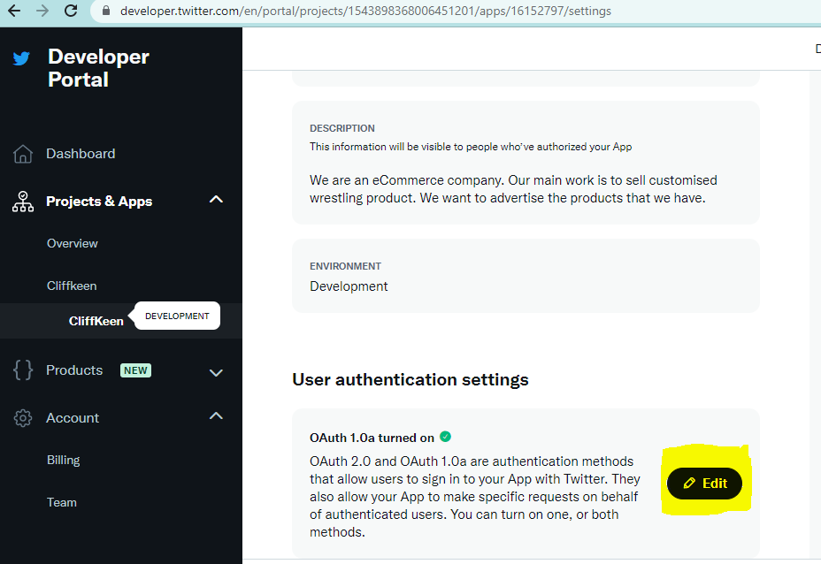

**Step-2** Add url of your web application

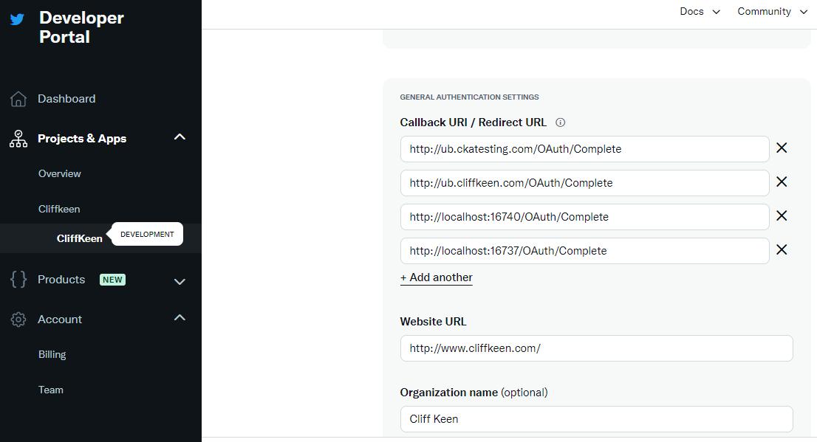

**Step-3** generate API Key and Secret key

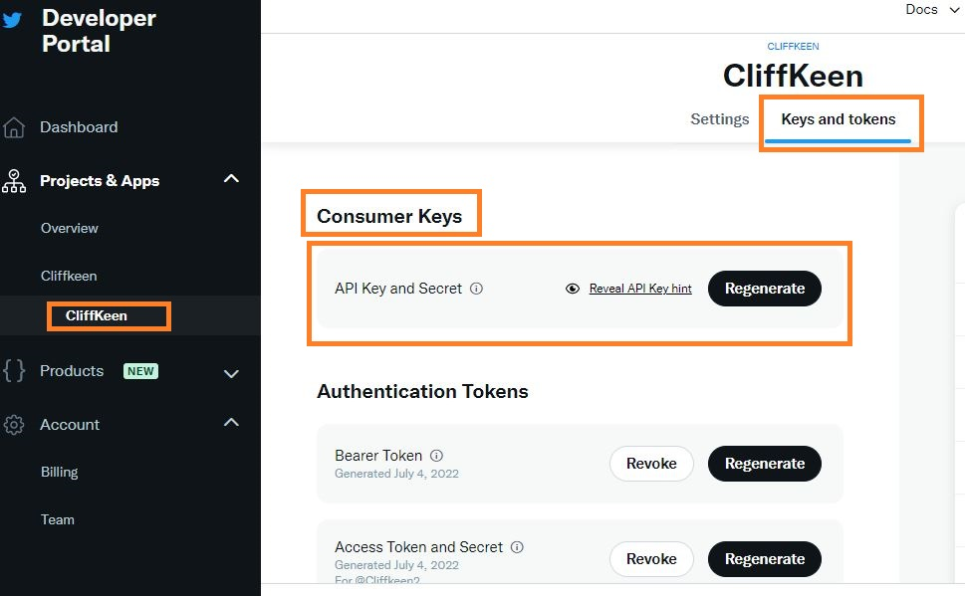

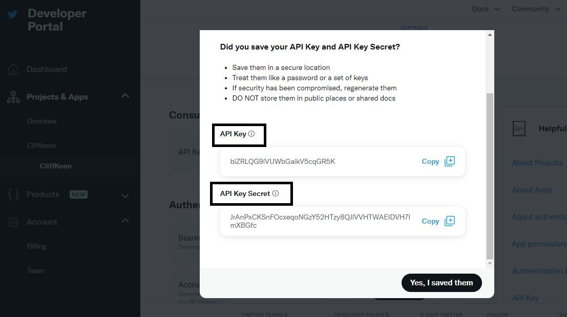

**2-Facebook**

Username: - ckub2019@gmail.com

Password: - @Password1

Associate phone no: - 7986113838

Associate Email id: - [ckub2019@gmail.com](mailto:ckub2019@gmail.com)

URL of developer account: - <https://developers.facebook.com/apps/>

